**Kubectl Logs**

**Step 1 :create python.yaml**

# git clone https://github.com/anilbidari/todorest.git

**Step 1.A : List the replica set**

# cd todorest

**Step 2 : create deployment**

# kubectl create -f todo.yaml

**Step 3 :List pods**

# kubectl get pods -o wide

**Step 4 :Get the logs for the pod**

# kubectl logs (pod-name)

**Step 5 : write the last lin of log to a file name log.txt in /home/ubuntu**

# vim /home/ubuntu/log.txt

**copy -last lines - Note last line content might be different for u**

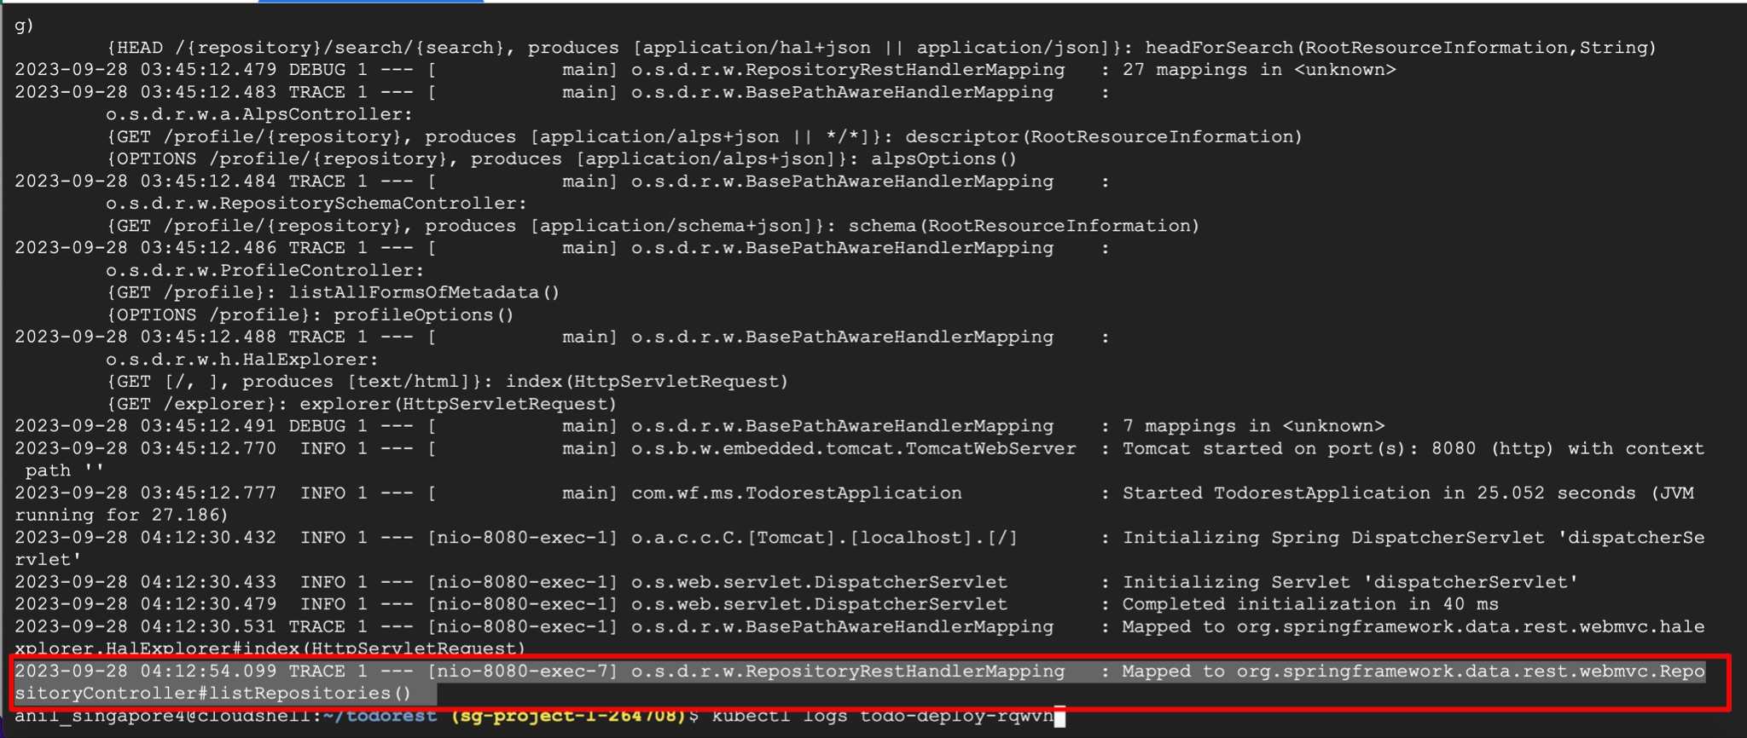

**Step 6 : cat the file to validate you have copied**

# cat log.txt



============================ completion of Lab =======================================